School Spending and Child Well-Being in the U.S.: Targeted Spending to Reduce Racial Inequality
Emily Rauscher, Greer Mellon, Susanna Loeb

Recent work using causal inference techniques consistently finds that students benefit from K-12 spending increases in the U.S. (Jackson & Mackevicius 2021; Candelaria & Shores 2019; Rauscher 2020a). Spending improves achievement, high school graduation, employment, and income, with larger benefits among low-income students and communities (Rauscher 2020a, 2020b; Rauscher and Shen 2022).
Relatively less is known about mechanisms: how spending benefits students or whether spending matters in different ways depending on student racial/ethnic background. Racial and ethnic inequality exists in every measure of health and educational opportunity (Chen et al. 2006; Smedley et al. 2003). Children spend about half their waking hours at school, which makes school context one important avenue for reducing racial and ethnic inequalities (Downey 2020).

1) Which types of spending mediate the effects of spending on child well-being?
2) How do mechanisms differ by student race/ethnicity?

We use close school district tax elections and regression discontinuity models to estimate effects of school operations spending on child well-being by race/ethnicity in 10 states in the U.S., 1995-2018. We compare districts that narrowly passed/failed a proposed funding increase. Within a narrow bandwidth around the cutoff required to pass, districts that pass/fail a funding increase are assumed to be similar except for voteshare, which is controlled. Multiple validity checks assess assumptions.
We examine multiple measures of wellbeing, including test scores and child mortality rates, calculated separately by race/ethnicity. We estimate how much each type of spending mediates the effects on well-being.

Preliminary Findings

Figure 1: Regression Discontinuity Density Plot
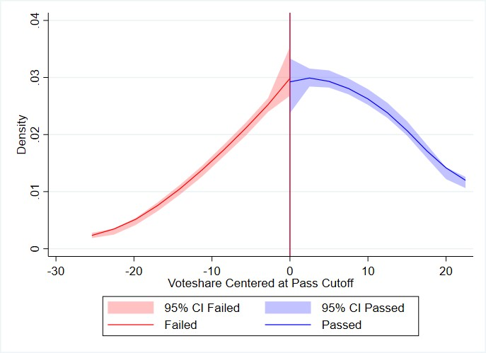
Density centered at the cutoff of the forcing variable, voteshare in favor of proposed tax increase.

Figure 2: Estimated Effect of Passing a Tax Election on Spending by Category
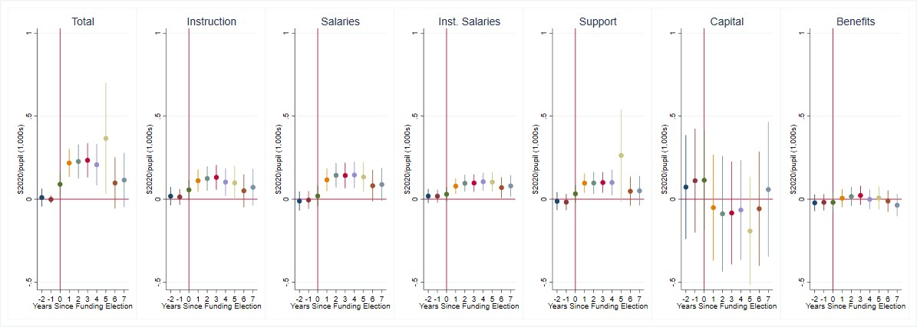
Regression discontinuity estimates of passing a tax election on district spending by category and time from the election. Spending is in thousands of 2020 dollars per pupil.

Figure 3: Estimated Effect of Passing a Tax Election on Achievement by Race/Ethnicity
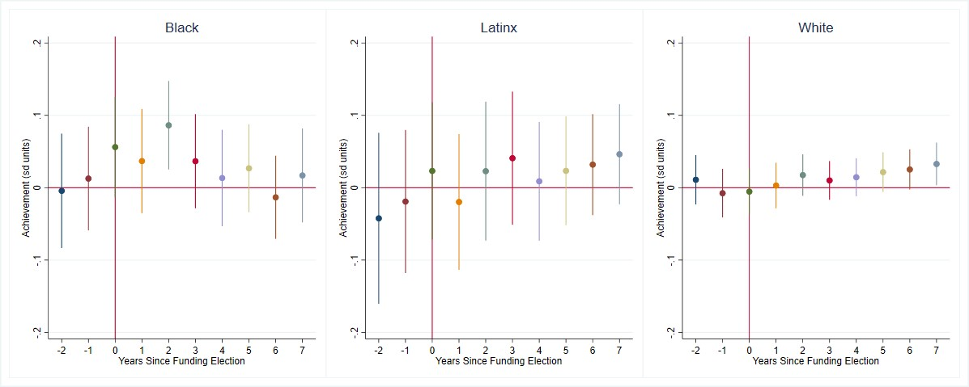

Regression discontinuity estimates of passing a tax election on achievement by race/ethnicity and time from the election. Achievement is measured in standard deviation units.

Figure 4: Estimated Effect of Passing a Tax Election on Child Mortality and Suicide
A. Child Mortality Rate (per 100k) B. Child Suicide Rate (per 100k)
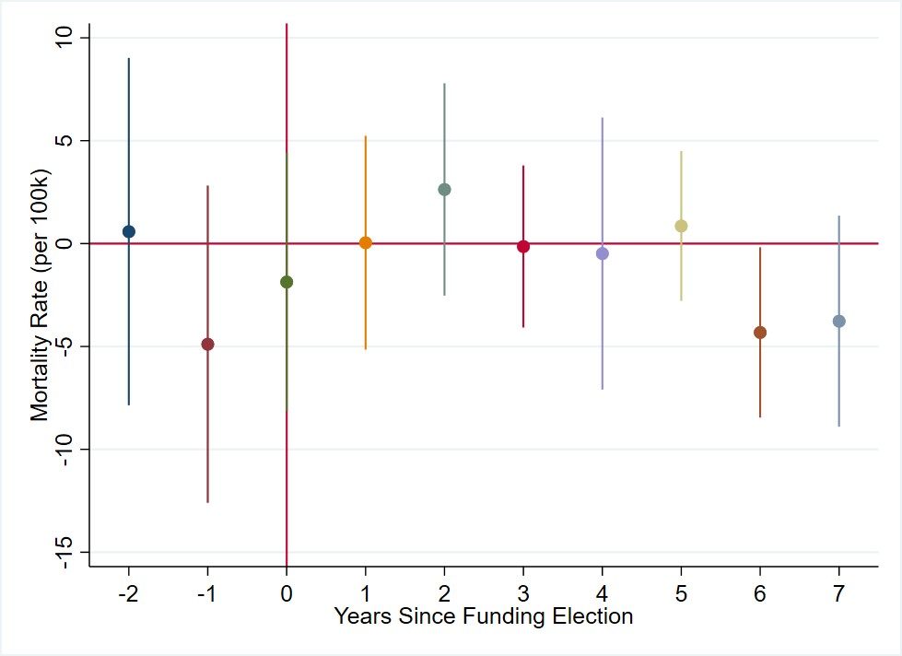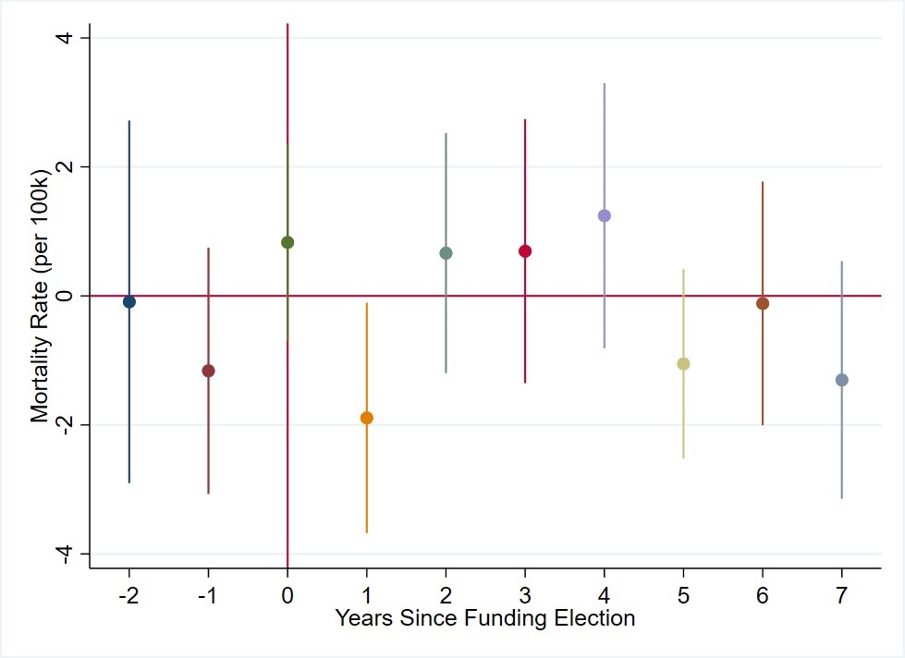
Regression discontinuity estimates of passing a tax election on child mortality rate (A) and suicide rate (B) by time from the election. Mortality and suicide rates are county rates for children ages 5-18 per 100,000.

Figure 5: Estimated Proportion of Main Effect of Passing a Tax Election Mediated by Spending Category
Panel A: Achievement
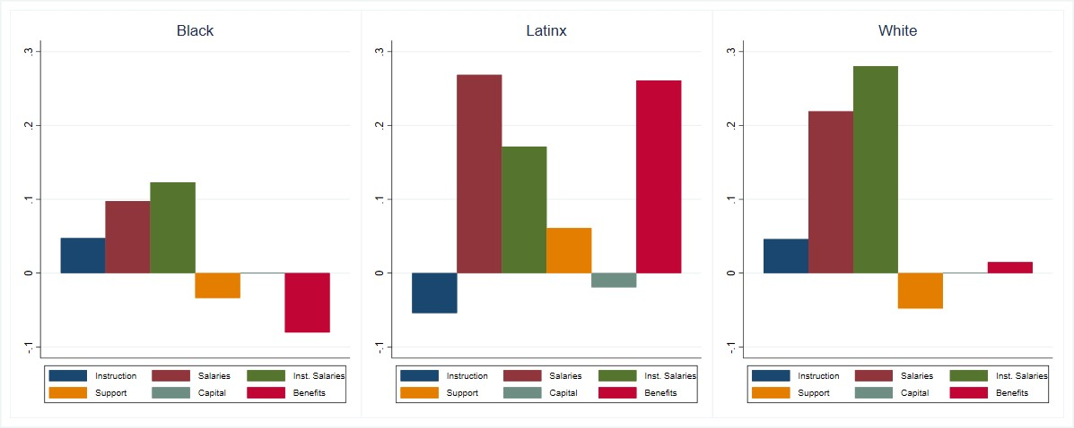

Panel B: Mortality
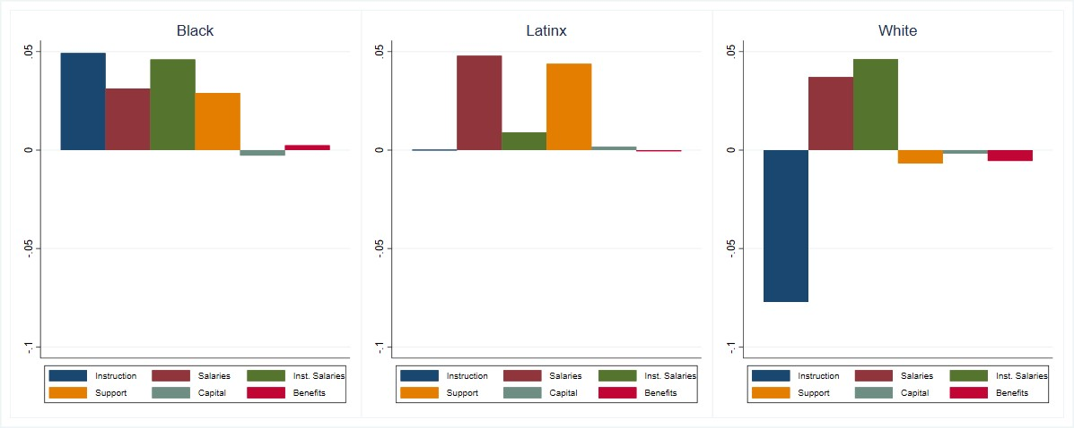
Under the strong assumption of sequential ignorability (SI) (Imai et al. 2011), mediation analyses estimate the proportion of the main effect on each child outcome mediated through each potential spending category. Estimates are associational. We estimate sensitivity of those estimates to violation of the assumption (medeff and medsens in Stata; Hicks & Tingley 2011).

