Beyond Convergence: Challenges in a New Land and the Depressed Fertility Among Migrant Descendants

José Luis Estévez & Anna Rotkirch
Population Research Institute, Väestöliitto, Helsinki, Finland

Abstract
This study uses administrative registers to investigate the patterns of parenthood initiation among different groups of migrant descendants in Finland. Discrete-time logistic models¹ reveal a pattern characterized by a higher likelihood of transition into parenthood for 1.5-generation migrants originating from high-fertility backgrounds compared to their native-born counterparts. This transition likelihood aligns closer with that of native-born individuals for the second generation and undergoes a reversal for the 2.5 generation (individuals born in Finland with a mixed migrant-native background) [see Figure 1]. We also conduct mediation analyses² to investigate the influences of education and partnership status [see Figure 2]. The findings indicate that while higher education levels foster parenthood initiation for men, the impact is comparatively weaker for migrant descendants. Additionally, while the absence of a partner acts as a significant deterrent for parenthood, affecting both men and women, this effect is stronger for migrant descendants compared to their native-born counterparts. Based on the observed patterns, we conclude that challenges in the local partnership market, coupled with what seems a need of larger investment in their professional careers for men, may offset the impact of cultural influences, offering an explanation for the puzzle of "depressed fertility" noted among migrant descendants in Finland and other contexts^{3–6}.

References
1. Singer, J. D. & Willett, J. B. Applied Longitudinal Data Analysis: Modeling Change and Event Occurrence. (Oxford University Press, 2003).
2. Karlson, K. B., Holm, A. & Breen, R. Comparing Regression Coefficients Between Same-sample Nested Models Using Logit and Probit: A New Method. Sociological Methodology 42, 286–313 (2012).
3. Andersson, G., Persson, L. & Obućina, O. Depressed fertility among descendants of immigrants in Sweden. Demographic Research 36, 1149–1184 (2017).
4. Delaporte, I. & Kulu, H. Interaction between childbearing and partnership trajectories among immigrants and their descendants in France: An application of multichannel sequence analysis. Population Studies 77, 55–70 (2023).
5. Dupray, A. & Pailhé, A. Does employment uncertainty particularly impact fertility of children of North African immigrants in France? A gender perspective. Journal of Ethnic and Migration Studies 44, 401–424 (2018).
6. González-Ferrer, A., Castro Martín, T., Kraus, E. & Eremenko, T. Childbearing patterns among immigrant women and their daughters in Spain: Over-adaptation or structural constraints. Demographic Research 37, 599–634 (2017).

Figure 1. Marginal effects by age (standardized) and group for men
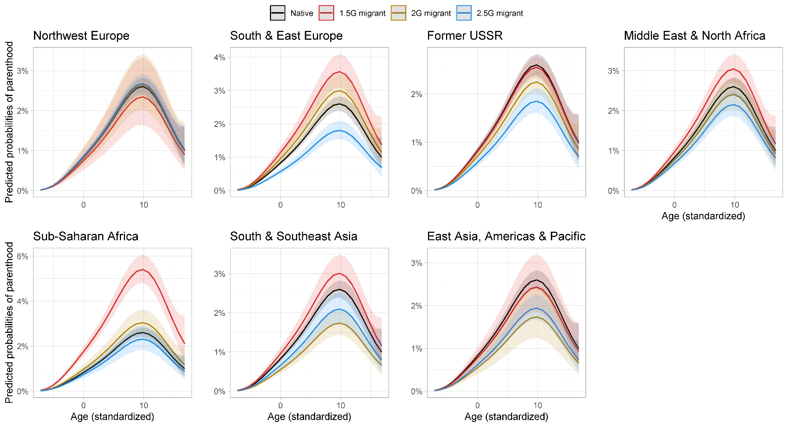

Figure 2. Indirect effects via education and partnership status (KHB method) for men.
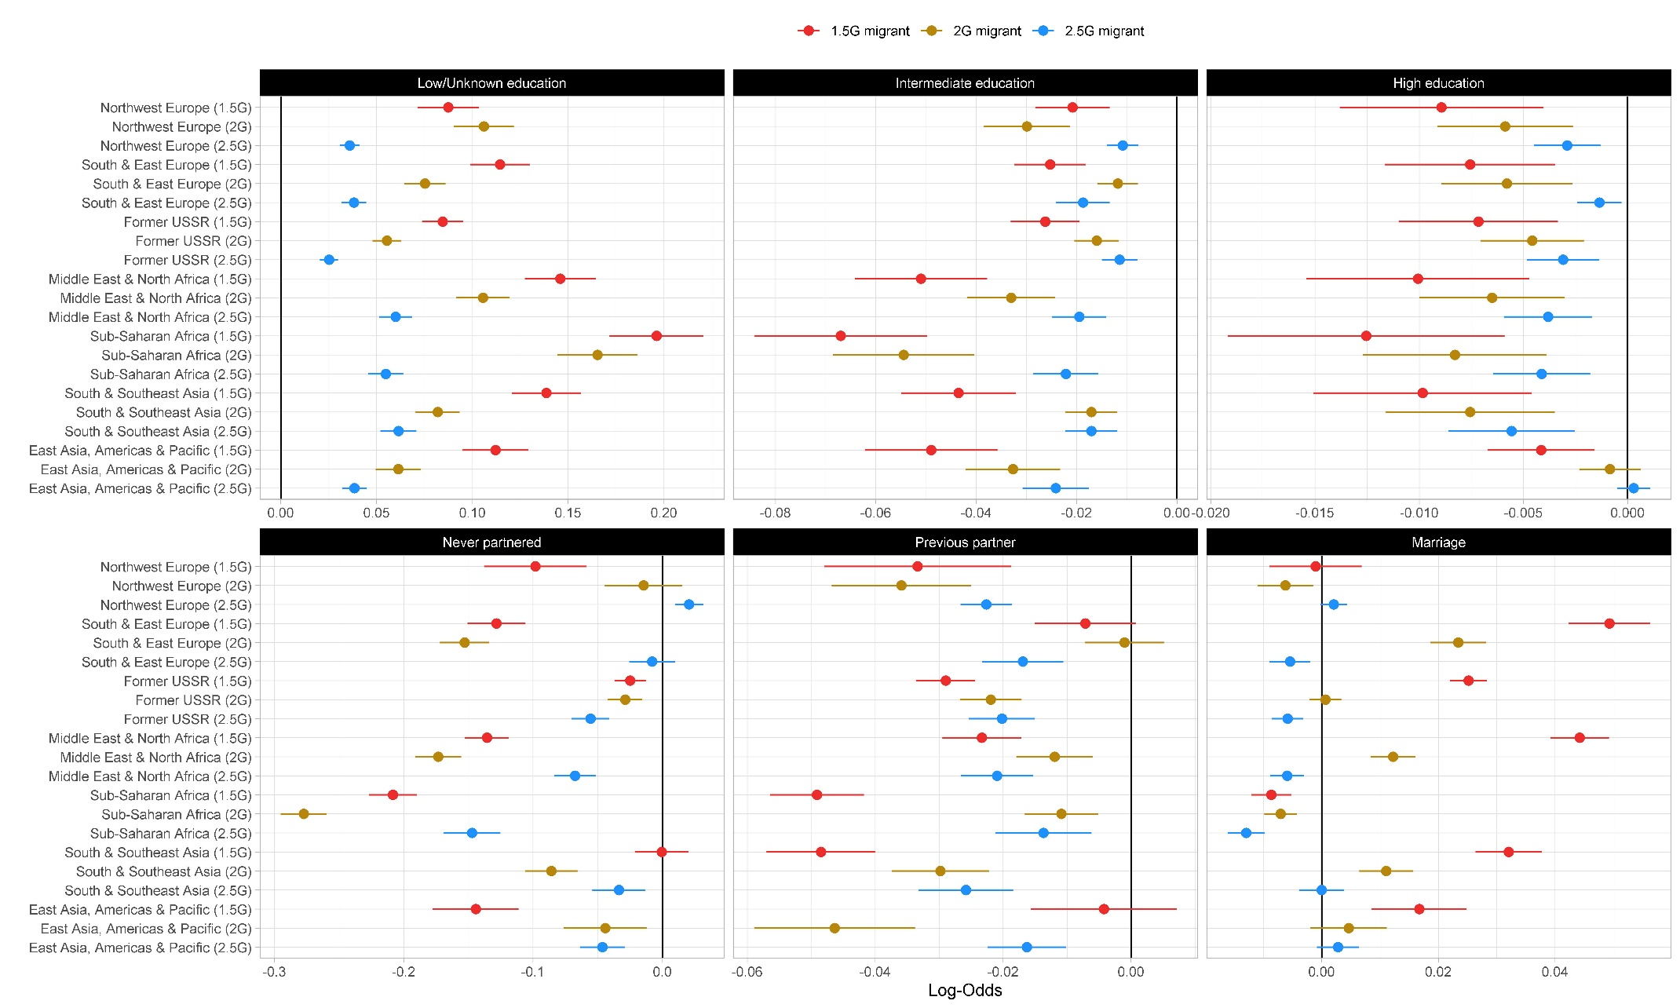
Caption: Error lines represent 95% confidence intervals

